Storm Drain Outfall Marking and the Spill Reporting

Program in the Saanich Peninsula



Veins of Life Watershed Society

February 11, 2001

Introduction

Storm outfall water quality in the Capital Regional District is managed by the CRD’s Stormwater Quality program. In 1997/1998, the CRD conducted this program to identify, inventory, and test the quality of all stormwater discharges along the coast of the Saanich Peninsula, Victoria, including the Gorge Waterway. A number of these outfalls were found to have unacceptable levels of fecal coliform and chemical contamination. Some were considered to pose serious environmental and public health concerns.

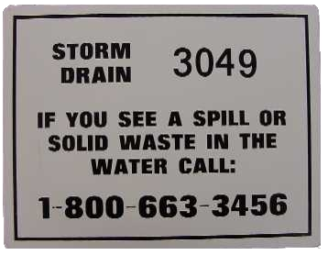
In accordance with The Veins of Life Watershed Society’s mandate to protect the integrity of our waterways, a project has been implemented to post signage on all outfalls in the project area. The project area for this report includes the Municipalities of Sidney, North Saanich, and Central Saanich, and the First Nations Lands of Union Bay, Cole Bay, South Saanich, and East Saanich (Appendix A). The signs (Figure 1) bear a number for each outfall and when possible, a listing of the Provincial Emergency Program Number: 1-800-663-3456. The first number provides for easy location and sourcing of a reported spill site and the second is designed to ensure that immediate action can be taken to remedy the problem. Both public and local government participation is essential for this program to be successful. Any spills observed must be reported promptly to enable the mobilization of an effective response.
Figure 1: Example of sign for outfall 3049, at the Swartz Bay Ferry Terminal

Methods

Permission from the local municipality or district was obtained before outfall marking commenced. Where outfalls were located on private property, permission was also granted from landowners. The location of each outfall has been identified by map and description in the report: Stormwater Quality Survey: Saanich Peninsula-1998, prepared by CRD Engineering. These maps and descriptions were used to locate and access each outfall site. Sign installation at each outfall involved either drilling the signs into the material surrounding the stormdrain or erecting signposts where drilling was impossible.

Table 1: Equipment Used

Power Drill (cordless):
Carbide masonry bits
Steel drilling bits

Hilti gun
- Lead anchors
- Outfall signs:
Large (containing outfall and PEP numbers)
Small (outfall number only)

Personal protective equipment
Safety glasses
Steel-toed boots
Hard hats and safety vests
- First aid kit

Hammer

Two types of signs were utilized in this project. The larger of the two signs (Figure 1) measured 18 cm (h) x 28 cm (w) and displayed the outfall number and the message, “Storm Drain – If you see a spill or solid waste in the water call: 1-800-663-3456”. These signs were posted in areas where visibility and accessibility were high or where health or environmental contaminants were of moderate or high concern. At these sites, there was more potential and more need for public participation in spill reporting. Smaller 10 cm x 10 cm signs contained only the outfall number for inventory purposes. These were posted at sites that were more isolated or in areas of low visibility.

The anchoring of signs into surrounding material was accomplished using a power drill for concrete or sandstone and a Hilti gun for harder concretes (Table 1). First, holes were drilled into the signs using a steel-drilling bit. Carbide masonry drill bits were then used to bore into the surrounding material. Lead anchors were hammered into the holes to secure the sign in place. Finally, the inventory number for the outfall was placed onto the sign (Figure 2).

For harder material, either a Hilti gun or steel T-posts were used. The Hilti gun was used where there was a concrete retaining wall, but the concrete was thick with stones. Charges were loaded into the gun and the setting was adjusted to accommodate for various surfaces before the sign was permanently secured. Steel signposts were erected at sites where there was frequent public use and/or drilling was impossible. This was often the case on sandy beaches or rocky outcrops where there was no concrete retaining wall out of which an outfall could flow. Posts were three-foot steel T-posts. Steel 3/16 size rivets attached the signs to the posts at the tops and bottoms of the sign. A flat surface on the post where the sign was attached was accomplished by grinding the top five or six nubs off of each post.

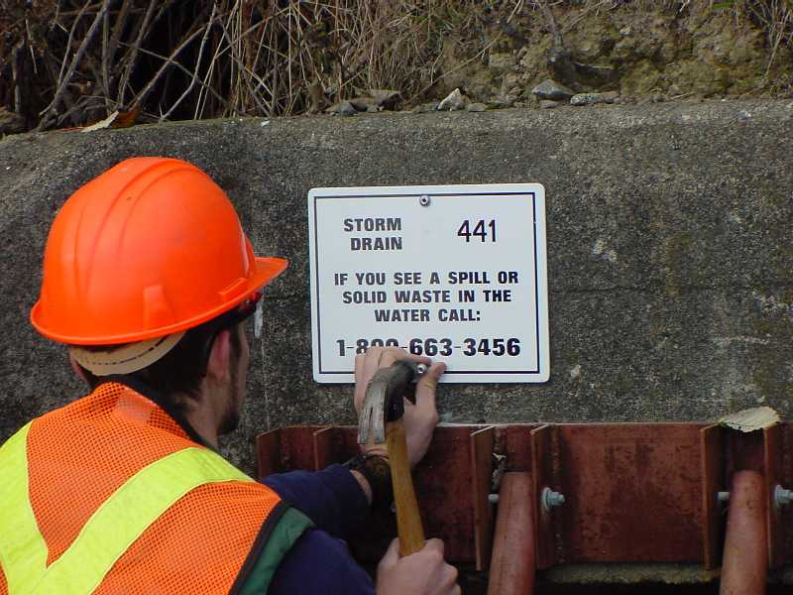

Figure 2: Outfall 441 sign installed using lead anchors

Results

From a total of 254 potential sites 204 were successfully marked with signs leaving 43 incomplete (Table 2). Summary data for this project can be found in Appendix B. There were a variety of reasons sites were not completed, including: (1) Could not locate; (2) Unable to obtain permission from private landowners; (3) Inaccessible (i.e. cliff), and; (4) No spot to install sign/post.

Table 2: Outfall Marking Results

Observations

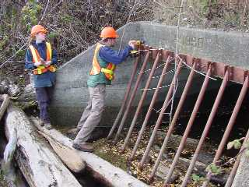
Safety: A Project Safety Analysis (PSA) was completed by all crewmembers prior to undertaking any outfall marking. This exercise ensures that all safety precautions are met and possible hazards are accommodated. The use of personal protective equipment (Table 1, and Figure 3, below) was found to prevent possible injury. Special care was taken around outfalls that were determined to have significantly high levels of contamination.
Figure 3: Charlie and Crystal use a hammer action drill, with hard-hats, vest, and eye protection to install a sign in Central Saanich
Organization: It was beneficial to ensure that all equipment was organized to enable easy transportation over unpredictable terrain to ensure efficiency and safety of movement. A significant amount of trekking and searching was required to locate some sites.

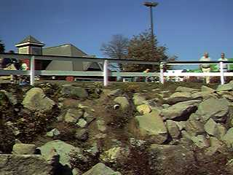
Drilling: Using a drill with a hammer action setting was useful, especially for more difficult surfaces. Also, the number of batteries available can be a limiting factor in productivity, as some surfaces require extensive drilling and can drain power quickly. The Hilti gun was found to be most effective at anchoring signs in most surfaces. However, it is considerably expensive to use all the time, and is a safety concern. Only qualified personnel operated the Hilti-gun. It was not possible to drill or nail using the Hilti-gun in granite. This was a common problem encountered in ripraps that compose much of the built-up coastal environment (Figure 4).
Figure 4: Granite riprap along coast of Sidney requires a signpost

Private property issues: Many outfall sites were located in areas that involved crossing private property to access them. Permission from owners or residents was attained prior to sign posting. It was found that very few people were reluctant to allow passage while some requested to speak with authorities in the local government. However, in some cases, property owners viewed the placing of signs on their property as an indication that there was poor water quality on their property and were more reluctant.

Public interest: The Storm Drain Marking Project elicited substantial public interest within the communities involved. Residents had many questions regarding the purpose of the signs and the PEP number. Some owners had information to share about historically observed discharge from the outfalls.

Conclusions

The spill reporting/outfall marking program at the Veins of Life is an ongoing process. As use and enjoyment of the waterways increases, more and more people are becoming stewards of the local environment by reporting contamination and dumping in their neighborhoods. The stormdrain marking project is an important step in ensuring the integrity of the Capital Regional District’s coastal waters. The signs help to enable effective outfall monitoring and reporting as well as providing a tool for immediate action in response to spills or other contamination. As the project depends upon cooperation between both the CRD and the community, it shows that we are all stakeholders of our coastal waters and therefore are responsible for its stewardship and protection.

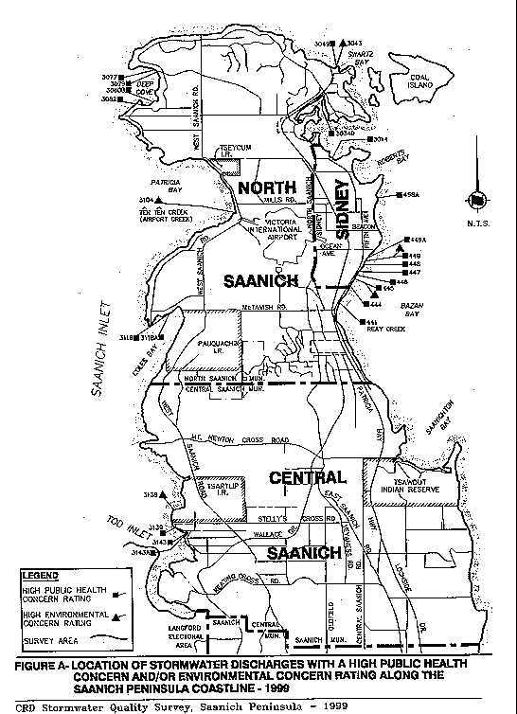
Appendix A: Saanich Peninsula Outfall Marking Area Map

Appendix B: Outfall Marking Summary Information

Overall Outfall Marking Summary - As of February 11, 2001
Sign Type | Number
Completed | 204
Incomplete | 50
Total | 254
North Saanich Outfall Marking Summary
Sign Type | Number
Completed | 110
Incomplete | 18
Total | 128
* Includes Cole Bay and Union Bay Reserves
Central Saanich Outfall Marking Summary
Sign Type | Number
Completed | 42
Incomplete | 21
Total | 63
* Includes East Saanich I.R. & S. Saanich I.R.
Sidney Outfall Marking Summary
Sign Type | Number
Completed | 52
Incomplete | 11
Total | 63
Posts Needed | 5

